

**Screenshot of code:-**

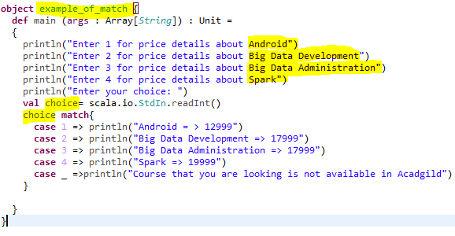

**SAMPLE OUTPUT 1:-**

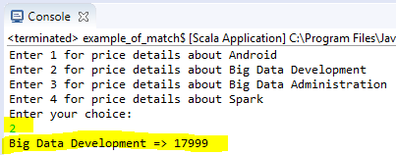

**SAMPLE OUTPUT 2:-**

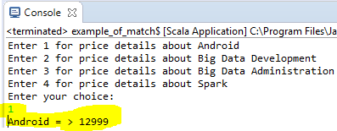

**PROGRAM CODE:-**

**object** example_of_match {

**def** main (args : Array[*String*]) : Unit =

{

println("Enter 1 for price details about Android")

println("Enter 2 for price details about Big Data Development")

println("Enter 3 for price details about Big Data Administration")

println("Enter 4 for price details about Spark")

println("Enter your choice: ")

**val** choice= scala.io.StdIn.readInt()

choice **match**{

**case** 1 => println("Android = > 12999")

**case** 2 => println("Big Data Development => 17999")

**case** 3 => println("Big Data Administration => 17999")

**case** 4 => println("Spark => 19999")

**case** _ =>println("Course that you are looking is not available in Acadgild")

}

}

}